|  |  |  |
| --- | --- | --- |
|  | **Department of Computer Science**  **Computer Networks**  **Due: Sunday 4th October (23.59)** | **Your name:** Ýmir Þórleifsson  TA Name: Jón Pétur  Time Taken: 7  Estimated Time: 6 hours |

**This is an individual assignment**

This assignment can be submitted as a pdf using Canvas. For those who like to dabble in the dark arts, the latex version is also available, but you may submit in any legible form you wish. Marks are awarded for question difficulty. While there is typically a relationship between difficulty and length of answer, it may not be a strong one.

**Explain your answer or give full derivation of results where appropriate. Solitary solutions without explanation risk receiving 0 points, even when correct. In particular if there are 2 points for a short question, 1 of them will be for the explanation.**

Optional: Please include a rough estimate of how long it took you do the assignment so that we can calibrate the work being assigned for the course. (The estimated time is provided purely as a guideline.)

|  |  |  |  |  |
| --- | --- | --- | --- | --- |
| Question: | 1 | 2 | 3 | Total |
| Points: | 8 | 10 | 12 | 30 |
| Score: |  |  |  |  |

# Ipv4 Subnetting

1 *8 points*

Being able to look at a subnet specification, and list the range of the host IPs is a useful, but rather non-obvious skill to master in networking. It is also quite often used to screen job applicants. The purpose of this question is to help you learn it. The following material may be useful:

<https://www.cisco.com/c/en/us/support/docs/ip/routing-information-protocol-rip/13788-3.html>

1. (2 points) What is the network mask for a Class D address?

It is reserved for multicast and not further subnet masked

$$224.0.0.0/4$$

Uses the first 4 bits for the network portion.

1. (2 points) What is the network mask for a Class B address?

$$255.255.0.0$$

Uses the first two octets for the network portion.

1. (2 points) Using Classless Interdomain Routing(CIDR) notation, how many bits are set in the subnet mask of address 192.5.23.132/9

There are 9 set bits. The mask looks like this in binary:

$$11111111.10000000.00000000.00000000 \left(255.128.0.0\right).$$

1. (2 points) How many hosts does this subnet mask provide?

$$2^{23}-2=8,388,606 hosts.$$

Since the network portion took up 9 bits, that means that network manager can devide the remaining 23 bits into subnets and hosts.

2 *10 points*

1. (5 points) In the diagram below, subnet the Class C network of 10.5.12.0/24 into 5 subnetworks: List the CIDR and IP ranges of each subnet, and show how many hosts are assigned to each subnet.

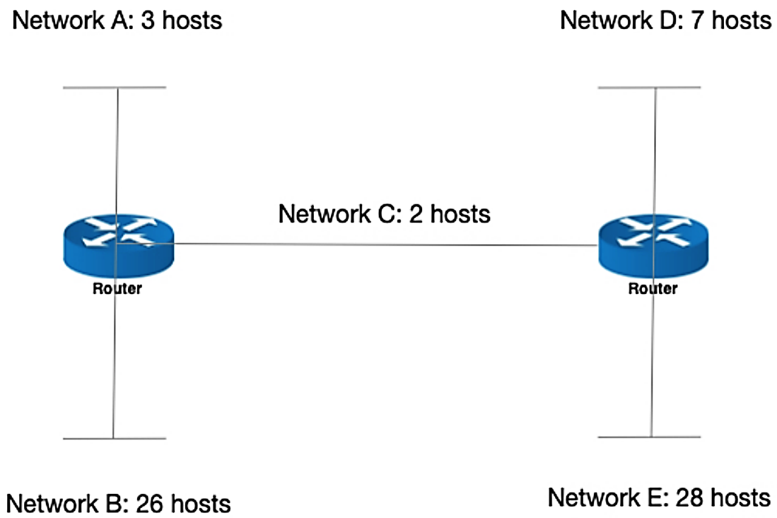

We have 5 subnetworks, requireing extra 3 bits ${(2}^{3}=8)$. The largest subnet must support 28 host addresses, $32-24-3=5$, $2^{5}-2=30$. This meets the requirement.

|  |  |  |  |
| --- | --- | --- | --- |
| Subnetwork | Hosts needed | Mask | Range |
| Network A | 3 | 10.5.12.0/27 | 1 to 30 |
| Network B | 26 | 10.5.12.32/27 | 33 to 62 |
| Network C | 2 | 10.5.12.64/27 | 65 to 94 |
| Network D | 7 | 10.5.12.96/27 | 97 to 126 |
| Network E | 28 | 10.5.12.128/27 | 129 to 158 |

84 addresses unused by the subnetworks.

1. (5 points) Variable length subnet masks (VLSM) is a feature on some equipment that allows different length masks to be used for each subnet, and consequently makes allocating address space more efficient.

<https://www.tutorialspoint.com/ipv4/ipv4_vlsm.htm>

Taking the same network as above, develop a subnetting scheme using VLSM with the following requirements:

|  |  |
| --- | --- |
| netA | Support 16 hosts |
| netB | Support 2 hosts |
| netC | Support 5 hosts |
| netD | Support 28 hosts |
| netE | Support 15 hosts |

Once again, list the CIDR and IP ranges for each subnet, and show how many hostIP addresses are available in each subnet.

We start with finding space for the largest networks and do it in this order; Network D, A, E, C, B.

|  |  |  |  |
| --- | --- | --- | --- |
| Subnetwork | Hosts needed | Mask | Range |
| Network D | 28 | 10.5.12.0/27 | 1 to 30 |
| Network A | 16 | 10.5.12.32/27 | 33 to 62 |
| Network E | 15 | 10.5.12.64/27 | 65 to 94 |
| Network C | 5 | 10.5.12.96/29 | 97 to 102 |
| Network B | 2 | 10.5.12.104/30 | 105 to 106 |

32 addresses unused by the subnetworks.

3 *12 points*

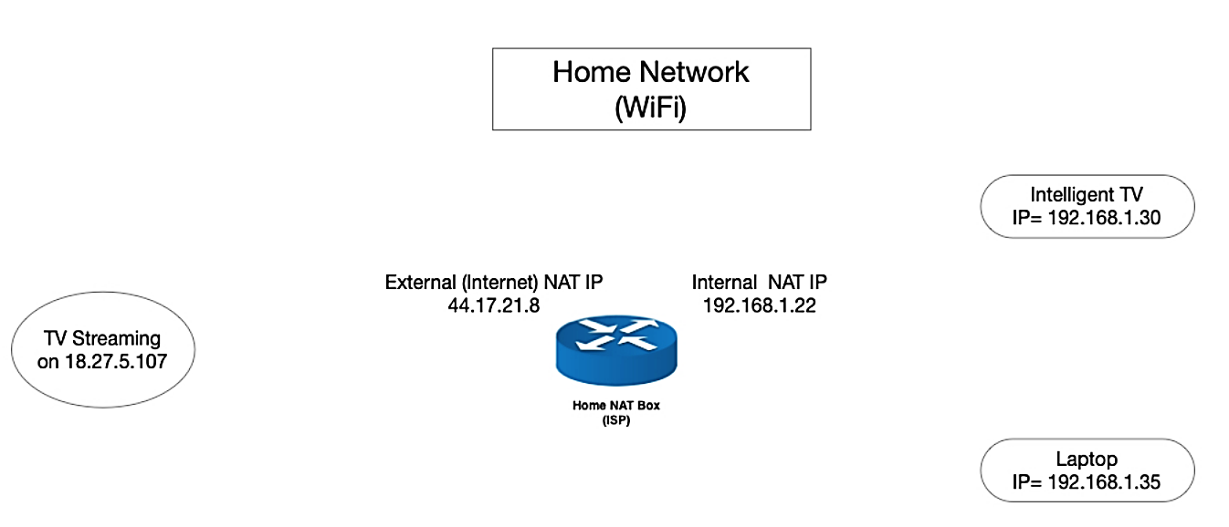

The diagram above shows a typical home network setup. The WiFi router which is acting as a NAT for the local network has an Internet IP address of 44.17.21.8, and an internal IP address (behind the NAT) of 192.168.1.22 There is also an Intelligent TV (Local IP 192.168.1.30) and a Laptop (192.168.1.35) also on the home network.

1. (4 points) In the diagram a TV is streaming a Movie on its port 8080 from port 54121 on the host providing the Internet TV stream at 18.27.5.107 Set out in a table, for each network port of the **round trip** between the orginating host and the destination, what address and port are being used. You may assign port numbers as appropriate where needed.

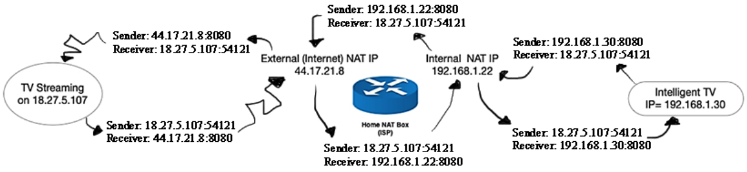The Intelligent TV might want to start streaming. It sends a package to the IP address: 18.27.5.107, port 54121 from its local IP address: **192.168.1.30**. The packages goes through the router and the Internal NAT of IP address: **192.168.1.22** translates the IP to a public IP: **44.17.21.8**. Only now can the package leave the local network to reach its destination to the TV Streaming on public IP address of **18.27.5.107**, port **54121**. The TV Streaming acknowlages this and starts sending packages to Intelligent TV‘s public IP: **44.17.21.8**. When it reaches the External NAT IP, it is transalted to the local IP: **192.168.1.22** and portforwarded back to the Intelligent TV of IP **192.168.30** and starts stream.

1. (3 points) If the Home NAT Box receives a packet from the Internet, addressed to 133.17.21.8, port 8080, what will it do with it?

The Home NAT Box will forward the packet to the Intelligent TV because it‘s listening and should be configured to portforward. Otherwise the package would be dropped.

1. (2 points) If the Laptop makes a broadcast to try and locate a printer, identify the devices that will receive the broadcast.

The laptop sends a broadcast looking for a DHCP server (the router) to ask for the IP address a printer, so all devices on the local network will receive the broadcast.

1. (3 points) What is the maximum number of connections a NAT box can support? Why?

$$2^{16}=65,536 connections$$

Because the mask is 255.255.0.0 leaving 16 bits for subnet addresses.